4

Two toy cars, red and blue, travel along a 2 metre track from opposite ends.

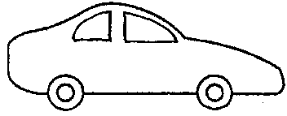
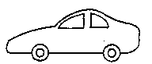
2 metres
START
red
START
STOP
blue

Both cars start at the same time.
They meet in the middle and stop.

(a) Which car was faster?

Tick ONE box ()

❑ | The red car.
❑ | The blue car.
❑ | Both had the same speed.

(b) All of the following statements are correct. But which is the best explanation for the answer above?

Tick ONE box ()

❑ | The cars travelled towards each other.
❑ | The red car travelled the same distance as the blue car in the same time.
❑ | The cars finished in the same place.
❑ | Another reason: _______________________________________  _____________________________________________________

